SCHOOL OF ALLIED SCIENCES, WARDHA (SAS)

**Banner 1:**   
**Where Industry Meets Education**

Future-ready UG & PG programs in AI, Healthcare Management, and Emerging Technologies.

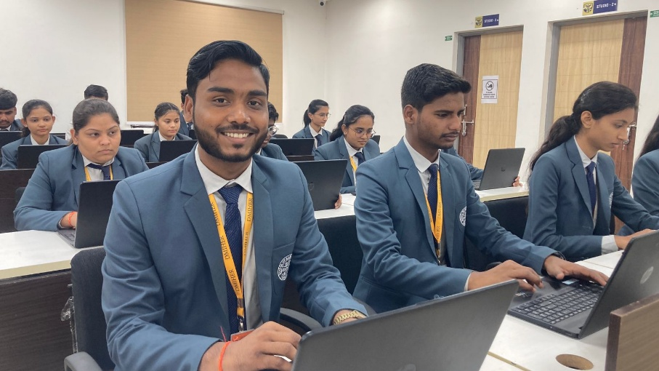

**Banner 2:**

**Global Immersion & Internship Ecosystem**  
Global immersion programs at NUS Singapore & UCSI Malaysia.

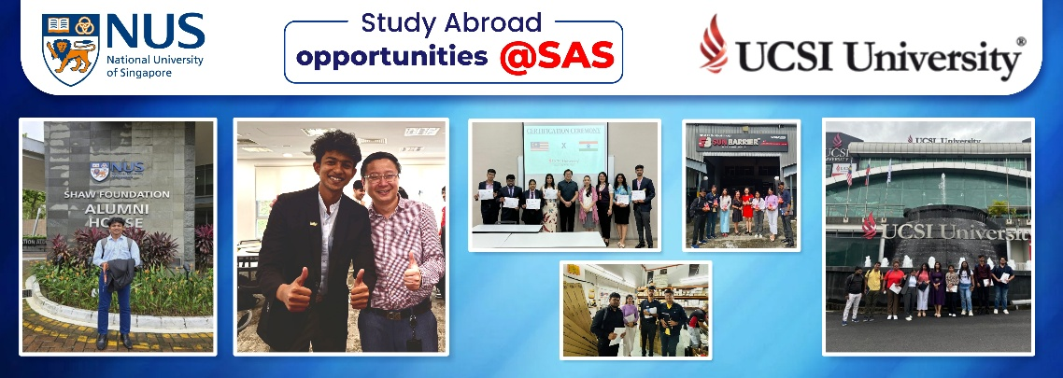

**Banner 4**

**Lead the Change:**

MBA in Hospital & Healthcare Management

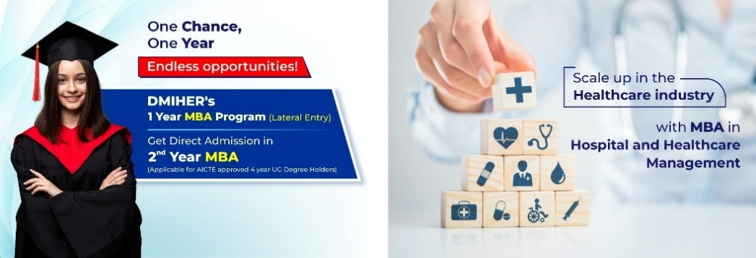

**On page content**

**Empowering Minds Through Health Technology, Arts and Leadership Management**

The School of Allied Sciences (SAS) at DMIHER (DU) offers a unique blend of management, technology, and healthcare education, SAS Houses Three faculties, i.e., Faculty of Commerce & Management Sciences, Faculty of Science & Technology and Faculty of Liberal Arts, Humanities & Social Sciences, providing 04 UG, 06 PG, and 05 PhD programs preparing students for careers at the intersection of health, technology, and leadership. With a strong focus on health IT, hospital management, and related fields, SAS integrates business acumen, technical expertise, and healthcare knowledge to develop innovative professionals for a rapidly evolving world.

Equipped with state-of-the-art infrastructure, industry-driven learning, and expert faculty, SAS emphasizes teamwork, collaboration, and hands-on experience to ensure students are globally competitive. Affiliated with DMIHER (DU), a NAAC A++ accredited university, SAS provides high-quality education and healthcare leadership training, shaping future industry leaders.

Next section

Why choose **School of Allied Sciences**

**Industry-Ready UG & PG Programs** in Healthcare Management, AI, Data Science, and Emerging Technologies.

**Hands-on Training & Placement** tie-ups with National Cancer Institute, Max Healthcare, TCS, Axis Bank, DMart, Ceinsys Tech AI, and more I Paid internships, on-the-job training, and placement support with 100% placement of previous batch. Avg. package: ₹ 4.5 LPA; Highest: ₹ 12 LPA.

**In-House Internship Ecosystem** with paid internships across healthcare, IT, banking, and education within Meghe Group institutions.

**Global** **immersion** programs with NUS Singapore & UCSI Malaysia; **Coursera** Campus access to 5000+ global certification courses from Harvard, Stanford, Google, IBM, and others.

**AI-driven Research & Innovation:** Startup incubation, 157+ papers, 24+ copyrights, 6 patents, and 81+ books. Home to 120+ PhD research scholars.

**Merit-based scholarships** and easy education loan assistance.

**Pursue two degrees simultaneously** through DMIHER’s dual-mode education system.

**OUR FACULTIES UNDER SAS**

**Faculty of Commerce and Management Sciences**

A Future-Driven Business Faculty under the School of Allied Sciences, DMIHER (DU)

The Faculty of Commerce and Management Sciences is a dynamic constituent unit of the School of Allied Sciences at DMIHER (Deemed to be University), a NAAC A++ accredited institution. Rooted in academic excellence and future-oriented pedagogy, the faculty equips students with the knowledge, skills, and strategic mindset needed to excel in today’s competitive global business landscape.

Offering a range of undergraduate to Ph.D. programs, the faculty emphasizes hands-on learning, research-based inquiry, and industry-integrated curriculum. It provides a unique edge by connecting core business education with emerging trends in healthcare and technology—hallmarks of the broader ecosystem at the School of Allied Sciences.

With a focus on innovation, ethical leadership, and entrepreneurial thinking, the Faculty of Commerce and Management Sciences prepares students to become transformative leaders and decision-makers in the world of commerce, management, and beyond.

**Faculty of Science and Technology**

Innovating Futures through Science and Technology at DMIHER (DU)

The Faculty of Science and Technology is a vibrant constituent department under the School of Allied Sciences, DMIHER (Deemed to be University), a NAAC A++ accredited institution. Committed to excellence in scientific inquiry and technological advancement, the faculty offers a range of undergraduate, postgraduate, and doctoral programs designed to nurture critical thinking, problem-solving, and innovation.

With cutting-edge infrastructure, a research-driven ecosystem, and industry-aligned curriculum, the faculty fosters interdisciplinary learning that bridges science, technology, and healthcare. Students gain practical experience and develop futuristic skills in areas such as data science, biotechnology, environmental science, and emerging technologies.

By integrating theoretical foundations with real-world applications, the Faculty of Science and Technology empowers students to become innovators, researchers, and technologists ready to address the challenges of tomorrow.

**Faculty of Liberal Arts, Humanities & Social Sciences**

Exploring Minds, Shaping Societies at DMIHER (DU)

The Faculty of Liberal Arts, Humanities & Social Sciences is a dynamic constituent department of the School of Allied Sciences at DMIHER (Deemed to be University), accredited with NAAC A++. Rooted in creativity, critical thinking, and cultural understanding, the faculty offers a rich array of programs designed to empower students with the tools to understand, interpret, and transform the world around them.

Blending academic rigor with real-world relevance, the faculty nurtures thought leaders, storytellers, researchers, and change-makers. Through interdisciplinary approaches, hands-on learning, and community engagement, students gain deep insights into human behavior, social structures, and global issues.

Whether through literature, psychology, sociology, or public policy, the Faculty of Liberal Arts, Humanities & Social Sciences inspires students to think deeply, communicate effectively, and act compassionately — equipping them to make meaningful contributions in diverse fields.

Next section

HOI’s Message

Dr. Chhitij Raj

HOI  
B. Com, MMS, PhD.

Email - [director.cdoe@dmiher.edu.in](mailto:director.cdoe@dmiher.edu.in)

Photo - 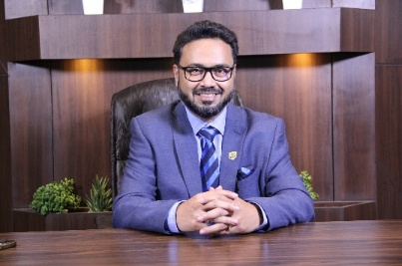

Welcome to the School of Allied Sciences (SAS) at Datta Meghe Institute of Higher Education and Research (Deemed-to-be University)!

At SAS, we are committed to providing a dynamic and holistic educational experience that blends management, technology, and healthcare. As a forward-thinking institution, we recognize the growing intersection between healthcare and other industries, and our programs are carefully designed to equip students with the skills needed to thrive in this evolving landscape.

Know more

***Next Section:***

Programs link (Rewrite the programs as provided below:

|  |  |  |
| --- | --- | --- |
| **Levels** | **Programs** | **Intake** |
| **Under Graduate** | BBA | 60 |
| BCA | 120 |
| BA | 10 |
| B.Com | 10 |
| B.Lib | 10 |
| **Post Graduate** | MBA | 60 |
| MBA-HHM | 60 |
| MCA | 60 |
| M.Com | 10 |
| M.Lib | 10 |
| **Ph.D** | Ph.D in Marketing Management |  |
| Ph.D in Human Resource Management |
| Ph.D in Finance Management |
| Ph.D in Operation Management |
| Ph.D in Science & Technology |

**Industry Partners and Collaborations**

* **Wadhwani Foundation** – Empowers students with entrepreneurial skills, startup incubation, and industry mentorship to drive innovation and business success.
* **Lemon Ideas** – A startup accelerator providing mentorship, incubation, and funding opportunities for aspiring entrepreneurs.
* **Coursera –** Global platform offering top university courses & certifications.
* **2COMS –** Recruitment partner providing national and international job placements, Internships and work integrated degree programs

***Next section***

**Holistic Learning and Infrastructure**

Tabs – with text on left and changing visuals on right

**Teaching–Learning Facilities**

Classrooms with smartboards, high-end projectors, Wi-Fi enabled campus.

Digital learning tools: LMS, ERP, Academic Book, Notebook, LRM, Coursera

**Laboratory Facilities**

24x7 access to well-equipped computer labs with high-end machines

**Associated hospitals**

Acharya Vinoba Bhave Rural Hospital, Shalinitai Meghe Hospital and Research Centre, Shalinitai Meghe Superspeciality Centre, Nelson Mother and Child Care Hospital, Siddharth Gupta Memorial Cancer Hospital

**Skill & Innovation Labs**

Programs based on Attitude Ethics and Communication, Life and essential skills trainings, GET-SET-GO Employability Training, CPR Courses (Basic life-saving trainings), IDEA LAB (Startup Incubator), BIONEST (Health-related Start-up Incubator)

**Research Facilities**

Research guidance, financial support for publications, Free access to IEEE Research Articles, Free access to Turnitin Software for Students and Staff is available

**Library Facilities**

Over 6131 books, 302 journal subscriptions, and Digital Library with 20 Computers having 2 GBPS speed.

Next Section link

Electives Offered

Know More

***Next section***

Research

**Engineering Ideas, Impacting Futures**  
Our vibrant research ecosystem encourages curiosity, critical thinking, and innovation across disciplines. From faculty-led projects to student-driven inquiry, we foster a culture where ideas are explored, tested, and transformed into meaningful impact.

**6 Patents**

**24 Copyrights**

**81+ Books Published**

**126+ Topics Published**

**157+** **Research papers published**

Next Section

**Global Opportunities at SAS (Study Abroad Opportunities)**

SAS offers multiple pathways for students to gain international exposure through semester abroad programs, research projects, immersion programs, and study tours. Through DMIHER Global, students have participated in programs at NUS Singapore, UCSI Malaysia, UC Berkeley, and Yeshiva University, New York—gaining insights into global best practices, research methodologies, and cross-cultural business environments. These experiences broaden their global perspective, enhance professional skills, and boost career prospects. The institute is actively working on new collaborations with universities in the US, Germany, UK, and Australia to expand these opportunities.

**Industry Partners and Collaborations**

***Wadhwani Foundation*** *– Entrepreneurial skills, incubation, and industry mentorship I* ***Lemon Ideas*** *– Startup accelerator with mentorship and funding support I* ***Coursera*** *– Global certifications from top universities and companies I* ***2COMS*** *– National and international placements, internships, work-integrated programs*

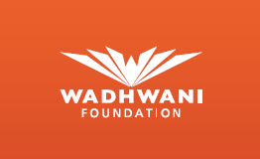   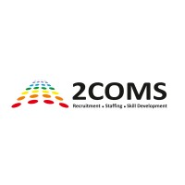

Next section

**Placement Opportunities**

SAS offers 100% placement assistance with a strong network of industry partners across healthcare, IT, retail, and banking sectors. Students have been placed with leading organizations such as Max Healthcare, TCS, Infosys, and Axis Bank, among others. With opportunities ranging from paid internships to full-time roles, the institute ensures hands-on industry exposure and career-ready training. The highest package offered has reached ₹12 LPA, reflecting the institute’s commitment to building strong, industry-aligned career pathways.

Logos

Next section

**Student Life at SAS**

With active clubs like the Academic Club, Quiz Club, Theatre, Dance, Music, Art, Fashion, and Sports Club—alongside impactful initiatives like the NSS, Youth Red Club, and Social Welfare Club—student life at SAS is dynamic, inclusive, and inspiring.

From energetic stage performances and fashion shows at our annual signature fest *Ignitra* to high-spirited sports nights under the floodlights, a vibrant mix of cultural events, sports, and student-led clubs fosters holistic development.

Gallery

Next section

Testimonials

Links on this page

Mandatory disclosure

FAQ